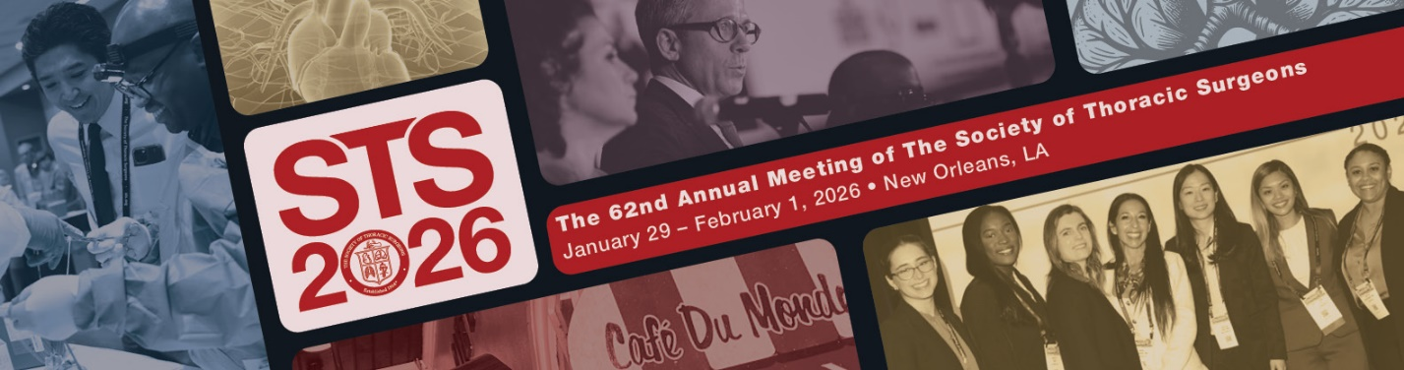

Annual Meeting Session Proposal Submission
DUE DATE: Tuesday, June 10, 2025
DO NOT EDIT FORM FIELDS

1. Proposed Session Title:

2. Proposed Moderators:
1.
2.

3. Submitter Name:

4. If you are submitting this on behalf of a workforce or task force, indicate the name here:

5. Session Description:

6. Learning Objectives:
Upon completion of this session, participants will be able to:
1.

2.

7. Does your session proposal feature a new and evolving topic that advocates for/or promotes practices that are not yet adequately based on current science, evidence, and clinical reasoning (off-label, etc.)? Yes or No.

If yes, please explain.

Session Proposals
All session proposals must be 60 minutes in length and adhere to the following structure:
- Each presentation must be 8 minutes long, followed by a 7-minute discussion.
Suggested formats include:
- Four presentations, each followed by discussion
- Two presentations followed by a group discussion
- Two presentations, discussion, then two additional presentations followed by discussion
IMPORTANT: This proposal is a template. If presentations/moderators/speakers are duplicated across other proposals the session may be altered, and it is at the discretion of the Annual Meeting Program Committee. If you have any questions regarding this, contact education@sts.org.

Duration | Presentation Title & Role | First Name, Last Name & Email | Profession
 | Moderator | Joseph Sabik, MD  test@sts.org | CT Surgeon
 | Moderator
8-minute presentation + 7-minute discussion | Update on Coronary Disease - Speaker | Joseph Sabik, MD  test@sts.org | CT Surgeon
8-minute presentation + 7-minute discussion
8-minute presentation + 7-minute discussion
8-minute presentation + 7-minute discussion

